A000-AM,C-Taino-Cemi-Owl-1000 CE

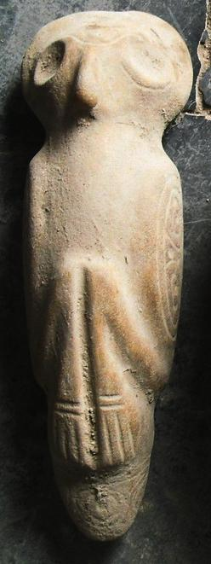 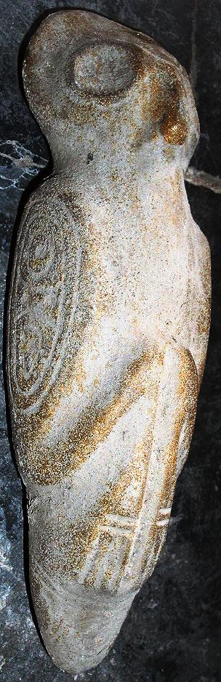

Case no. 18